|  |
| --- |
| **K. K. Wagh Polytechnic, Nashik.**  HirabaiHaridasVidyanagari, Amrutdham, Panchavati, Nashik-422003  **Department of Computer Technology** |



**Academic Year: 2023-24**

**Class: TYCM-Win Group No: 26 Date: _____________**

**Title of Project: Attendance Monitoring System Using Facial Recognition**

**Assignment No: 05**

**Name of Activity (Assignment): Project Exhibition Demonstration of project to faculty staff**

**Name: Mrs.Y.U.Kadam**

**Signature of Guide:**

* + The K.K. Wagh Polytechnic College organized a spectacular exhibition of the Computer Department, offering a platform for students to showcase their innovative projects and ideas. Amidst the bustling atmosphere of creativity and discovery, our team proudly presented The Attendance Monitoring System, a revolutionary project aimed at enhancing the way of marking attendance of students in educational institutes. As students from the first and second years gathered around our exhibit, we eagerly shared the remarkable features and capabilities of the system, capturing their attention with the promise of transformative technology.

* + During the exhibition at our college, we showcased the comprehensive capabilities of our system to the faculty, staff, and students, particularly those in the first and second years. We demonstrated how our system can seamlessly identify the facial objects from video frames, recognize the faces of saved students, and mark the attendance of present individuals. By doing so, we aim to promote inclusivity and empower individuals with hearing impairments to communicate effectively in various settings.

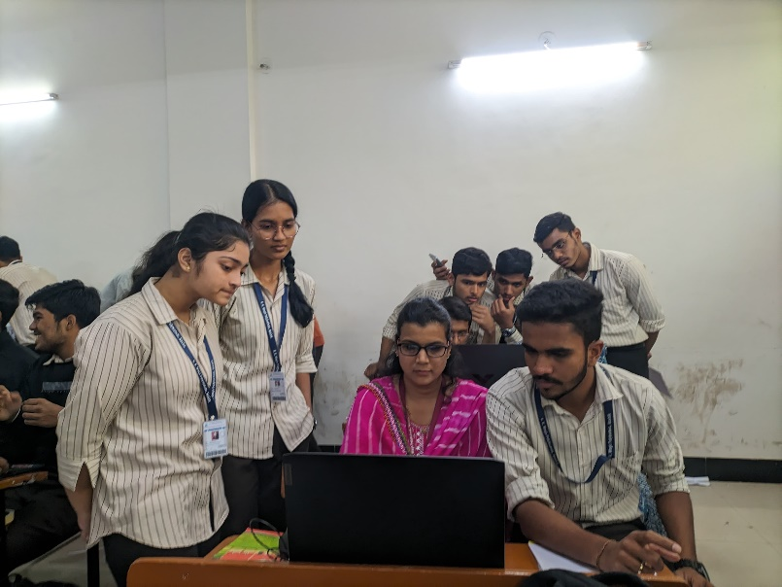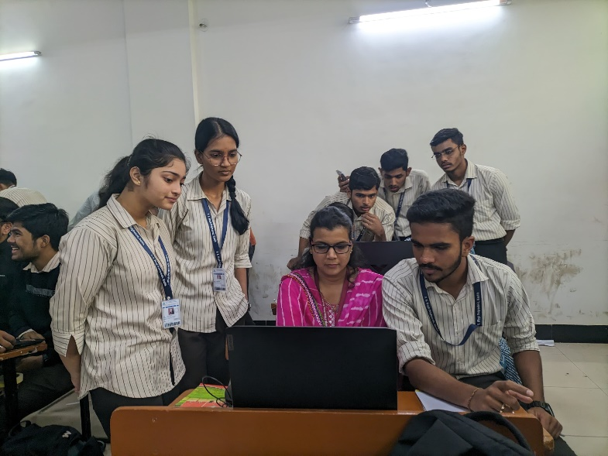

**With Mrs. K.N.Ahire**

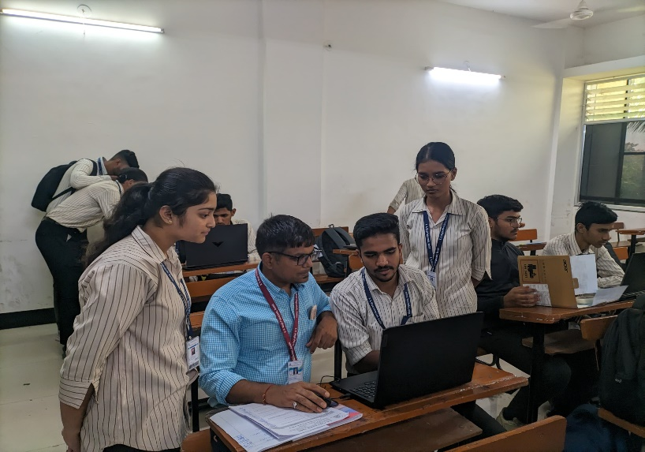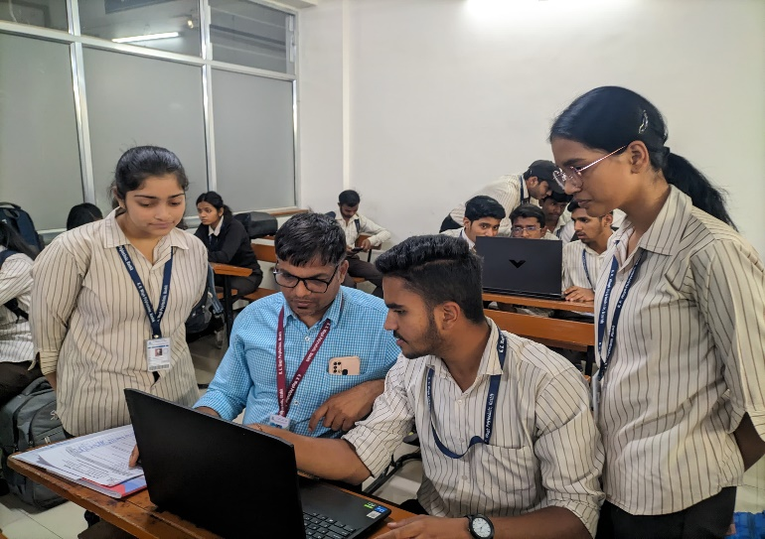

**With Mr. S.H. Sangale**

* + Furthermore, we encouraged students to interact with the system themselves, allowing them to experience firsthand how the system recognizes and interprets different facial features. By engaging with the technology directly, students gained a deeper understanding of its functionality and potential applications. Moreover, we encouraged them to provide feedback on their user experience, allowing us to continuously improve and refine the Attendance Monitoring System.
  + Overall, our engagement with students during the project exhibition not only showcased the innovative aspects of the system but also sparked curiosity and interest in the intersection of technology and accessibility.